|  |  |  |  |  |
| --- | --- | --- | --- | --- |
| |  | | --- | |  | |  | |  | |  | |
| Biofuels  Biocarburants |
| Auteur(s) : Cécile Canu  Adresse de messagerie : cecile.canu@gmail.com  Niveau : Première STL  Type d’enseignement : ETLV |

|  |  |  |
| --- | --- | --- |
|  |  |  |
|  |  | by-nc-sa  **Attribution - Pas d’Utilisation Commerciale - Partage dans les Mêmes Conditions** |
| Biofuels  Biocarburants |  | **Auteur(s) : Cécile Canu**  Adresse de messagerie : cecile.canu@gmail.com  Établissement : Lycée PGdG ENCPB Académie : Paris |
|  |  |  |

|  |  |  |  |  |  |  |  |  |  |  |  |  |  |  |  |  |  |  |  |  |  |  |  |  |  |  |  |  |  |  |  |  |  |  |  |
| --- | --- | --- | --- | --- | --- | --- | --- | --- | --- | --- | --- | --- | --- | --- | --- | --- | --- | --- | --- | --- | --- | --- | --- | --- | --- | --- | --- | --- | --- | --- | --- | --- | --- | --- | --- |
| Présentation  Comment mettre au point des carburants alternatifs ? Et ce, à partir d’huile de table ou d’algues. Cette ressource permet de répondre à ces questions à travers l’étude d’un mp3 et propose ensuite un jeu de cartes de révisions.  Référentiel, programme   * SPC : Chimie et développement durable (chimie face à l’environnement, synthèses organiques) * CBSV : Thème 1 : Les systèmes vivants présentent une organisation particulière de la matière (biomolécules et acides gras)   Compétences travaillées  Préciser ici la part de chaque compétence disciplinaire travaillée lors de l’activité.   |  |  | | --- | --- | | S’approprier | ■■■□ | | Analyser | ■■□□ | | Réaliser | ■■■□ | | Valider | ■■□□ | |  |  |   Niveaux de compétence en langue  Langue : Anglais   |  |  |  |  |  | | --- | --- | --- | --- | --- | | Comprendre | Écouter | ☐ A2 | ☑ B1 | ☐ B2 | | Lire | ☐ A2 | ☑ B1 | ☐ B2 | | Parler | Prendre part à une conversation | ☐ A2 | ☑ B1 | ☐ B2 | | S’exprimer oralement en continu | ☑ A2 | ☐ B1 | ☐ B2 | | Écrire | Écrire | ☑ A2 | ☐ B1 | ☐ B2 |   Mots clés  Anglais, ETLV, bioénergie, biocarburant, anglais, algues, CBSV, environnement |  | Niveau et type d’enseignement  Niveau : Première STL  Type d’enseignement : ETLV  Sources  Making fuel from vegetable oil (mp3) : <www.thenakedscientists.com>  Étapes de la séquence  **Évaluation :**  Possibilité d’évaluer la compréhension orale des vidéos. Les réponses sont proposées en fin de ressource.  **Séance 1 : 1 h**  Étude de l’enregistrement d’une interview  **Séance 2 : 1 h**  Jeu de Taboo : restitution orale |

Table of Contents

For students 2

PART 1 : KITCHEN SCIENCE : MAKING FUEL FROM VEGETABLE OIL 3

PART 2 : REACTION 6

PART 3 : PLAYING TABOO TO REVIEW THE ESSENTIALS 7

For teachers 10

PART 1 ANSWERS : MAKING FUEL FROM VEGETABLE OIL 11

PART 2 ANSWERS: REACTION 12

|  |
| --- |
|  |
| For students |
|  |

### PART 1 : KITCHEN SCIENCE : MAKING FUEL FROM VEGETABLE OIL

Scientists at Bath University, UK, have a found a simple way to use vegetable oil as fuel for car engines for example.

Here is an interview at Bath University by Azi, reporter from the Naked Scientists.

Source : <http://commons.wikimedia.org/wiki/File:Biofuels.jpg>

*STEP 1: Discover the recording*

<http://www.thenakedscientists.com/HTML/content/interviews/interview/760/>

Listen to the MP3 without looking at the transcript at least two or three times. STOP at “glycerol, which is just a waste product of the biodiesel process »

*Write down the keywords that you hear, then write them on the board:*

*________________________________________________________________*

*STEP 2: Rephrasing*

*Get into groups of 4-5 students. Using the keywords selected by the class, rephrase the main ideas in the MP3 :*

*__________________________________________________________________________________________________*

*After having written your summary, one student from each group should read it or explain it to the rest of the class.*

*STEP 3: Assisted listening*

*After a couple of listenings without the text, you may listen to the MP3 again but this time, read the text at the same time. Note that the main keywords appear in* ***bold lettering****.*

**Kitchen Science - Making Fuel from Vegetable Oil**

**Prof. Matthew Davidson, Prof. Gary Hallway & Chris Chuck, University of Bath**

Prof. Matthew Davidson, University of Bath Source:

[*http://www.thenakedscientists.com/HTML/content/interviews/interview/760/*](http://www.thenakedscientists.com/HTML/content/interviews/interview/760/)

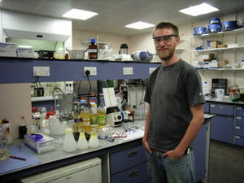

Azi - Hello, welcome to **Kitchen** **Science**. This week, I’ve come to the historic city of Bath and I’m actually standing at the university of **Bath’s** **Chemistry** **Department**, I’m joined by Professor [Matthew] Davidson and also Christopher Chuck who is a PhD student here. The question I’ve come to you guys with, and I’m really hoping you can help me out here, is can you run your car on cooking **vegetable oil**?

Matthew - That’s an interesting question as to whether you can run your car on **vegetable** **oil**, what’s chemically called a **triglyceride**, a molecule with three long fatty arms on it. What happens is they all just get **entangled** together, and that means it has a very high **melting** **point**. The two most important problems are; firstly the stuff would **freeze** in your **tank**, so on a slightly cold morning you would have a **solid** **mess** and the second problem is that it simply **doesn’t** **burn** very well.

Azi - Okay, so what’s the solution?

Matthew - Well the solution is actually quite a simple **chemical** **process**, and I can show you exactly how we do it. Before we do, I want you to put on some **goggles**, just to make sure we’re **safe**.

Azi - Okay, I’ve got my **goggles** on.

Matthew - Right, well what we’re going to do is were just going to take some **vegetable** **oil** that we bought at the **supermarket**, and we’re going to take this **mixture** here, which is **methanol** and **sodium** **hydroxide**. We’re just going to **mix** it with **vegetable** **oil**, you can see that the vegetable oil is **stirring** away with a stirrer in it, it’s **heated** **up** to about **60** or **70** **degrees** centigrade.

Azi - Okay, so you’ve got the **vegetable** **oil** in a **flask**, and you’re putting **sodium** **hydroxide** which is mixed with **methanol**, in the **measuring** **cylinder** and you’re going to **tip** it **in**…

Matthew - Yeah, we need to wait about half an hour and what we will see is the separate components; the biodiesel will **separate** **out** from the **by**-**product** which is called **glycerol**, which is the other part of the **fatty** **molecule** that we started off with.

Azi - So what’s the **chemical** **process** that is happening inside that **flask**?

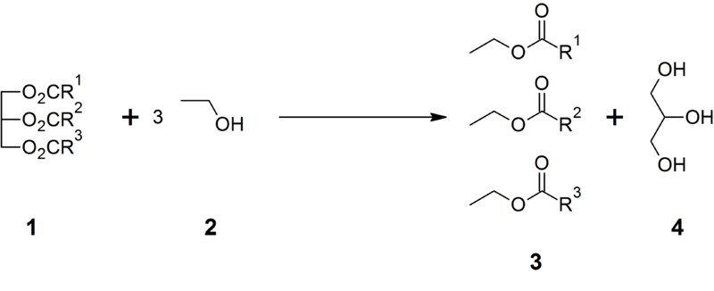

Matthew - Well the chemical process is something called **transesterification**, which is a bit of a complicated term for simply just changing the end of the long **fatty** **molecule** *(molecule 1)*. So instead of just having 3 of the fatty molecules attached to one end, a bit like a piano stool with three legs, we’re changing the end, just capping off the fatty molecule with **methanol** *(molecule 2)*. That give us individual fatty molecules, and that’s what is actually called **biodiesel** *(molecule 3),* that we could use in an **engine**; and another molecule called **glycerol** *(molecule 4)*, which is just a **waste** **product** of the biodiesel process.

**STOP!**

*STEP 4: Pair work on vocabulary*

*Get into pairs. Here some definitions, try to match them with the correct words found in the text above:*

|  |  |
| --- | --- |
| ***French or formula*** | **English** |
| *moteur* |  |
| *produit secondaire* |  |
| *Résidu, déchet* |  |
| *Corps gras* |  |
| *Éprouvette graduée* |  |
| *Agiter, mélanger* |  |
| *Lunettes de protection* |  |
| *geler* |  |
| *Réservoir de voiture* |  |
| *emmêlé* |  |
|  |  |
|  |  |

### PART 2 : REACTION

Fill in the blanks, on the left handside, the reactants, and catalyst, on the right handside, the products and catalyst.

Biofuel :

1)

2)

3)

 = 

Temperature =

### PART 3 : PLAYING TABOO TO REVIEW THE ESSENTIALS

On the next page, you will find taboo cards that will help you review the important vocabulary.

**Objective:** you have to make your team guess the word on the card you randomly pick without using the word itself or three additional words listed on the card. A team that guesses a word gets one point.

**How to play:**

* Get into two teams, decide on the teams’ names.
* Cut out the cards and place one set on the teacher’s desk.
* A student who gets a right answer gets to come to the front and make the others guess a word. He must first randomly pick a card from the pile.
* Students take turns to come to the front to make the others guess one word.
* The game stops after all 12 cards have been used.

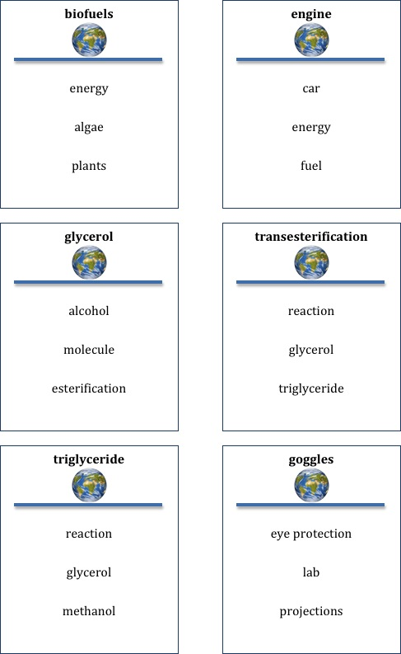

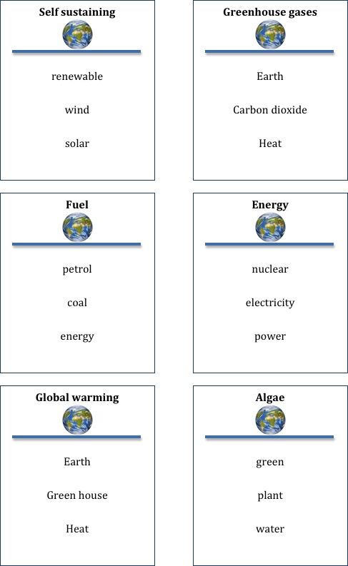

|  |
| --- |
|  |
| For teachers |
|  |

### PART 1 ANSWERS : MAKING FUEL FROM VEGETABLE OIL

*STEP 4: Pair work on vocabulary*

|  |  |
| --- | --- |
| ***French or formula*** | **English** |
| *moteur* | engine |
| *produit secondaire* | By product |
| *Résidu, déchet* | Waste product |
| *Corps gras* | Fatty molecule |
| *Éprouvette graduée* | Measuring cylinder |
| *Agiter, mélanger* | To stir (or to mix) |
| *Lunettes de protection* | goggles |
| *geler* | To freeze |
| *Réservoir de voiture* | tank |
| *emmêlé* | entangled |
|  | glycerol |
|  | triglyceride |

### PART 2 ANSWERS: REACTION

glycerol

Biofuel :

3 esters

triglyceride

 = 

Hydroxide ions

Hydroxide ions

methanol

Temperature = 60 to 70°C